3.2.1 INSTITUTION HAS CREATED AN ECOSYSTEM FOR INNOVATIONS AND HAS INITIATIVES FOR CREATION AND TRANSFER OF KNOWLEDGE

IIC-HMV IS RECOGNIZED WITH 4-STARS BY INNOVATION CELL-MOE DURING THE YEAR 2021.
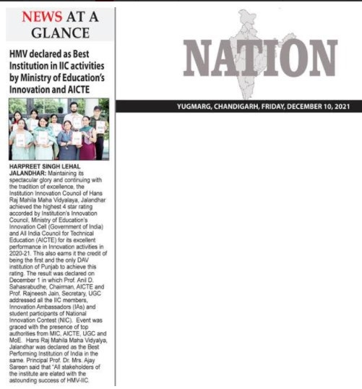
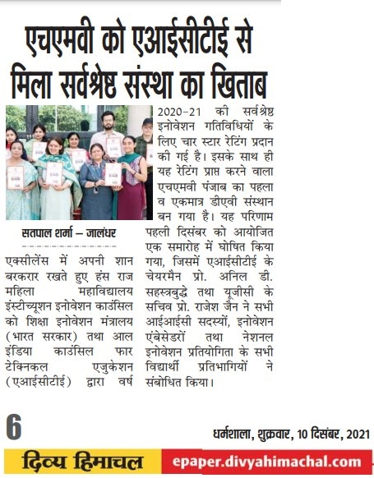

HMV BECAME THE ONLY COLLEGE OF GNDU TO BE DECLARED AS A PERFORMER INSTITUTE IN ARIIA RANKINGS
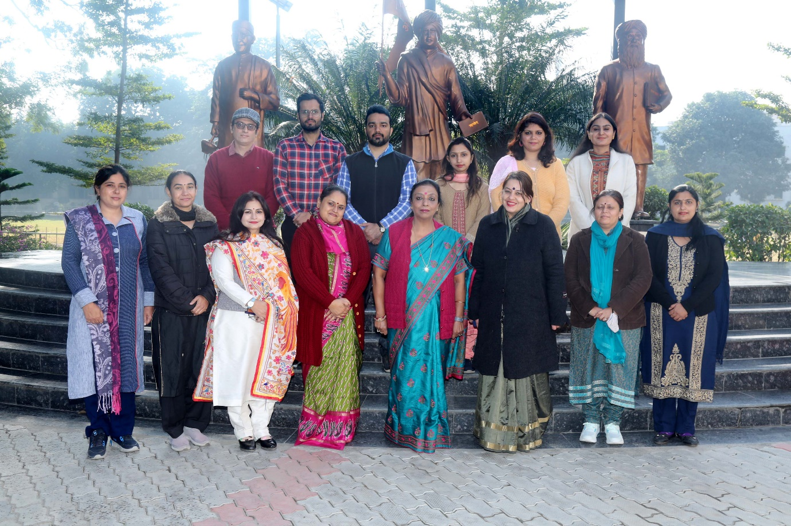
Hans Raj Mahila Maha Vidyalaya, Jalandhar was declared as a Performer Institute in Atal Ranking of Institutions on Innovation Achievements (ARIIA) rankings which were announced by the Ministry of Education on 29th December, 2021. Hon'ble Minister of State, Dr. Subhas Sarkar, Ministry of Education, Govt. of India graced the occasion as Chief Guest. The premier institute, Hans Raj Mahila Maha Vidyalaya, Jalandhar was assessed on various parameters like innovation ecosystem, entrepreneurship development, teaching learning among others and was placed in the Performer Institute Band. Expressing her delight over HMV's phenomenal performance, Principal Prof. Dr. (Mrs.) Ajay Sareen said: “Today, HMV is a brand of its own. This achievement is due to the sheer hard work of the students, staff, faculty members, our alumni and the vision of the torch bearers of this institute, our mentors at DAVCMC New Delhi and our mentors of Local Committee.''

WEBINAR ON DESIGN THINKING ORGANISED BY HMV
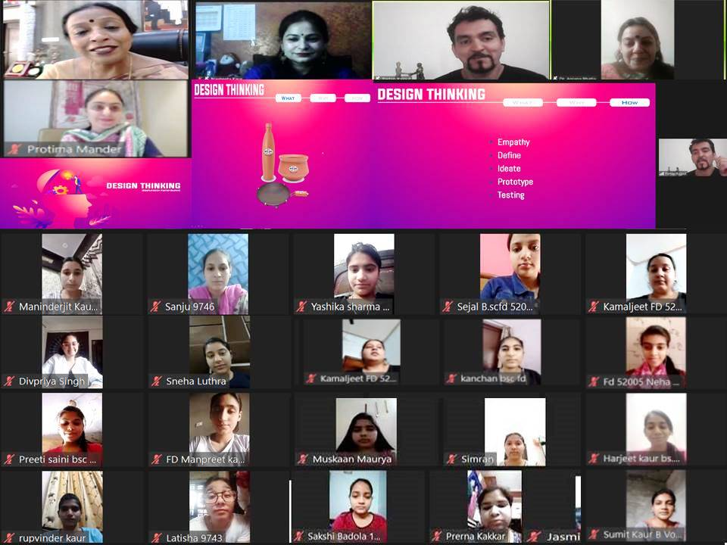
Hans Raj Mahila Maha Vidyalaya hosted an online session on “Design Thinking” under the initiative of Institutional Innovation Council with the inspiration of Principal Prof. Dr. (Mrs.) Ajay Sareen. The session began with the recital of Gayatri Mantra. President IIC Dr. Anjana Bhatia gave a formal welcome to the Resource Person Mr. Partap Rajput. Mr. Partap Rajput introduced the concept of Design Thinking. He described Design Thinking as the backbone of the Solution to any problem. It is the process of finding the problem, thinking design and finding solution. It is a process of solving problems by prioritizing customer needs above all else. He Discussed what, why and how of design thinking. He gave lots of examples to make students understand the concept of “Design Thinking”. Design thinking Follows – Empathy, Defining the problem, ideate, Prototype and testing the dummy design

HMV ORGANIZED ONLINE SESSION ON SUCCESSFUL STARTUP FOUNDER LESSONS
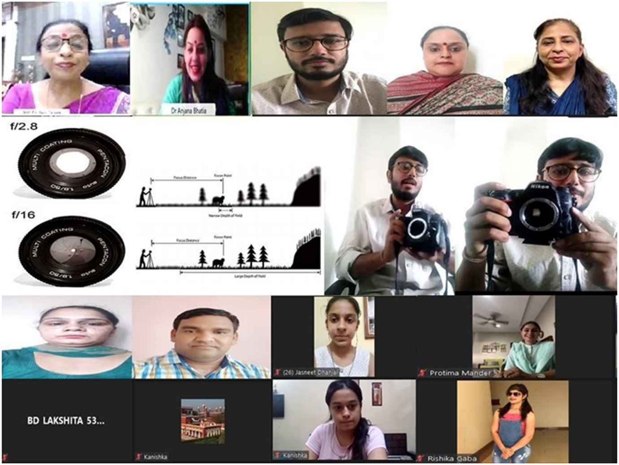
Hans Raj Mahila Maha Vidyalaya Jalandhar conducted online session on successful startup Founder Lessons by Mr. Mohit Bhandari under the aegis of Institutions Innovation council. The session started with words of enthusiasm by Principal Prof. Dr. Mrs. Ajay Sareen. The session continued with words of welcome by Dr. Rakhi Mehta, head Design Department. Mr. Mohit Bhandari, Renowned Businessman and Photographic Artist was resource person of the session. He talked and discussed about various photographic techniques, light and effects, fleeting aspects of light. He also discuss about types of cameras and its handling. Mr. Mohit answered start up queries and challenges faced by designers and artists in photography world. He also emphasized on use of digital aspects and technology in the life of artists and designers.

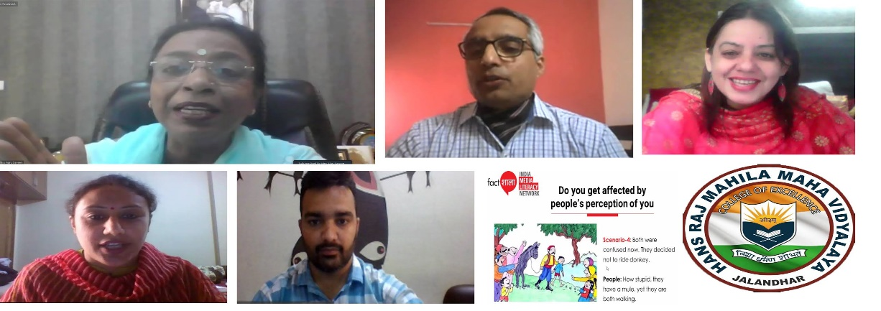
HMV ORGANISED “FACTSHALA” INDIA MEDIA LITERACY NETWORK WORKSHOP
The PG departments of Mass Communication and Video Production and Multimedia of Hans Raj Mahila Maha Vidyalaya organised “Factshala, India Media Literacy Network workshop. The resource person of the workshop was Prof. Umesh Arya, Chairman, Department of Communication Management and Technology, Guru Jameshwar University of Science and Technology, Hisar, Haryana. Principal Prof. Dr. Mrs. Ajay Sareen welcomed him and said that while it is difficult to control the flow of information, media and information literacy can lessen the impact of this problem by developing media and information literacy competencies amongst people. She said that there is a need to have concerted efforts to make people media and information literate so that they can sail smoothly in the sea of information and media messages. Mrs. Rama Sharma, Head of PG department of Mass Communication and Video Production department welcomed him and gave his brief introduction. She also gave the concept note of the workshop.

HMV ORGANIZED WEBINAR ON CRITICAL THINKING

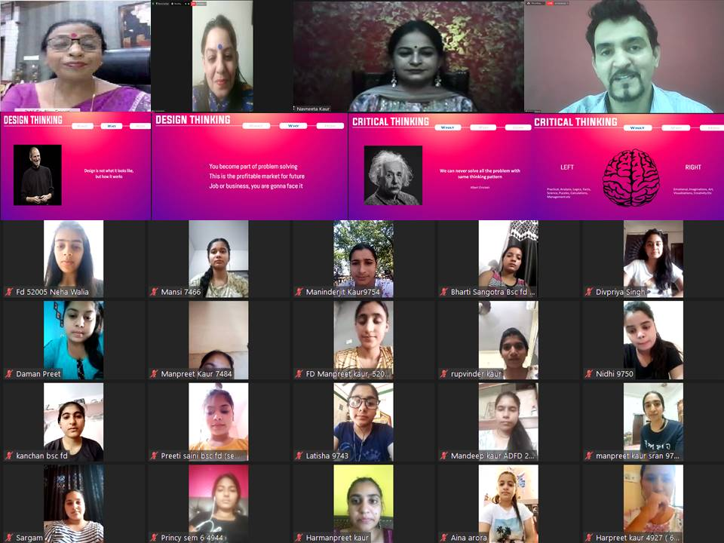
Hans Raj Mahila Maha Vidyalaya hosted an online session on “Critical Thinking” under the initiative of Institutional Innovation Council with the inspiration of Principal Prof. Dr. (Mrs.) Ajay Sareen. The session began with the recital of Gayatri Mantra. President IIC Dr. Anjana Bhatia gave a formal welcome to the Resource Person Mr. Partap Rajput.Mr. Partap Rajput started the session by re-touching the design thinking process, which was followed by the concept of Critical Thinking. He described Critical Thinking as a process to develop the brain in such a way that people do not simply accept what comes their way but rather question and come to a conclusion with evidence and facts. He also insisted on theory by Albert Einstein that “We can never solve a problem with same thinking pattern”. What, why and How of Critical thinking was also discussed along with importance and uses of critical thinking. Students also learnt different stages of Journey in Critical Thinking.

INNOVATION COUNCIL OF HMV ORGANISED ONLINE SESSION ON “BUSINESS MODEL CANVAS”
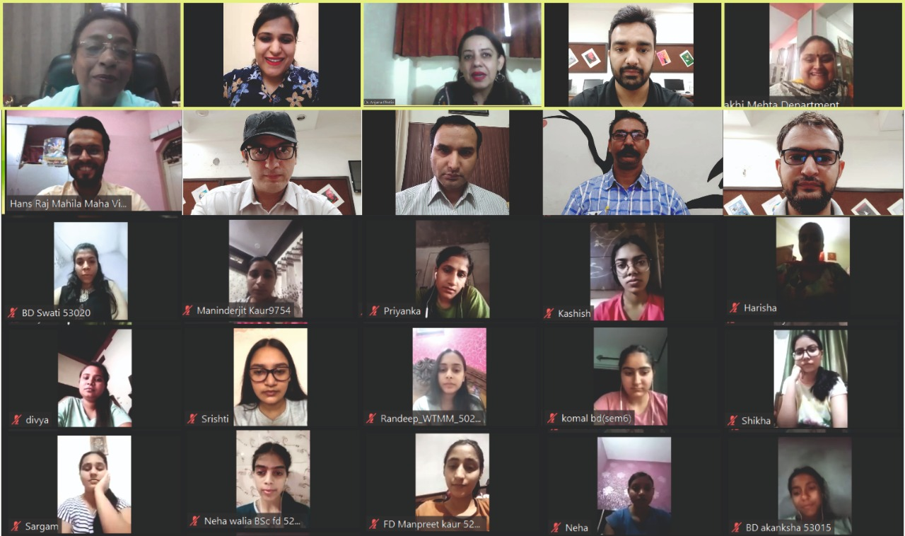
Institutional Innovation Cell of Hans Raj Mahila Maha Vidyalaya, Jalandhar in collaboration with PG Department of Multimedia organized an online session on Business Model Canvas under the aegis of MHRD to acquaint the students towards Entrepreneurship. Principal Dr. Ajay Sareen conveyed her best wishes and congratulated the Innovation Cell for its incessant efforts. She also applauded the Innovation Ambassadors for successfully organising the Sessions. Dr. Anjana Bhatia introduced the concept of the session and briefed about the MHRD’s motive of Innovation Council which is prompted towards training the youth of the country and gave a formal welcome to the Resource Person Ms. Leena Chhabra. Ms. Leena Chhabra a young entrepreneur, Director Clients Code Working actively as WICCI -State President Punjab Digital Media Council started the session by explaining the basic concept of Business Model Canvas in a very simple way. She emphasised that the concept of entrepreneurship. Right from the basic level of Entrepreneurship to all the 9 blocks of Business Model Canvas.

STUDENTS OF HMV PREPARED INNOVATIVE TOYS FOR TOYCATHON-2021
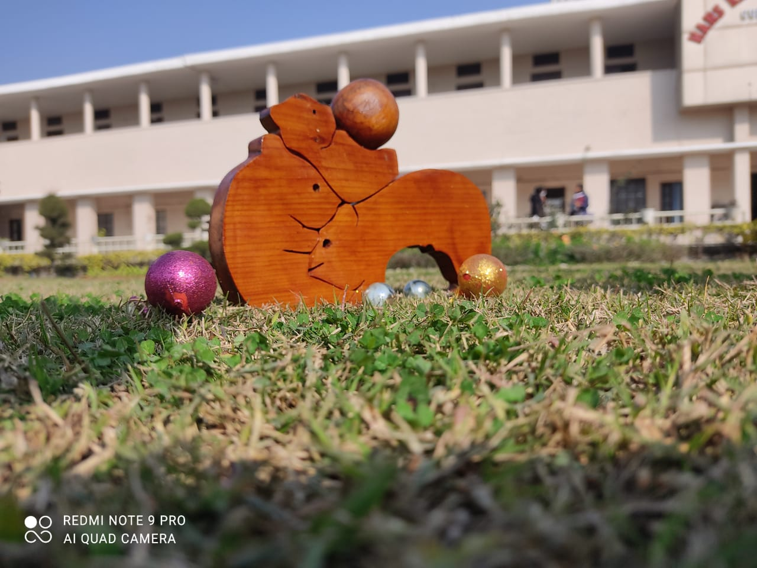
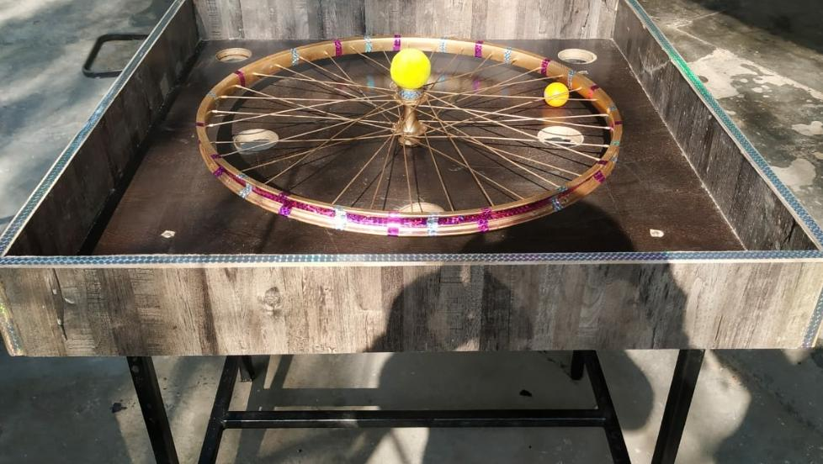

Under the able guidance of Principal Prof. Dr. (Mrs.) Ajay Sareen, students from various departments of the college participated enthusiastically in Toycathon-2021 which is an inter-ministerial initiative organized by Ministry of Education’s Innovation Cell with support from All India Council for Technical Education, Ministry of Women and Child Development, Ministry of Commerce and Industry, Ministry of MSME, Ministry of Textiles and Ministry of Information and Broadcasting.

Dr. Anjana Bhatia, Incharge-Institution Innovation Council told that eight teams participated under the mentorship of their teachers. Dr Rakhi Mehta and team prepared a physical toy for toddlers called Fuzzy Wuzzy. Dr Shailendra and his team prepared an indigenous game using recycled products Chakke mein gaind. Other toys like Bharat Ke Shoorveer, Chumbkiye Firqi, Environmental Ludo, Meri Peehu, Constitutional Ludo etc were prepared under the mentorship of Mr. Jagjit Bhatia, Mr. Gurmeet Singh, Mr. Gullagong, Mr. Sushil Kumar, Mrs. Protima Mander and Ms. Simmi. All the ideas were highly appreciated. Principal Dr Ajay Sareen congratulated the students and faculty and encouraged them to draw inspiration from their ancient heritage, culture and wisdom to develop innovative ideas and discover new opportunities.

IDEA PITCHING COMPETITION-2021 AT HMV

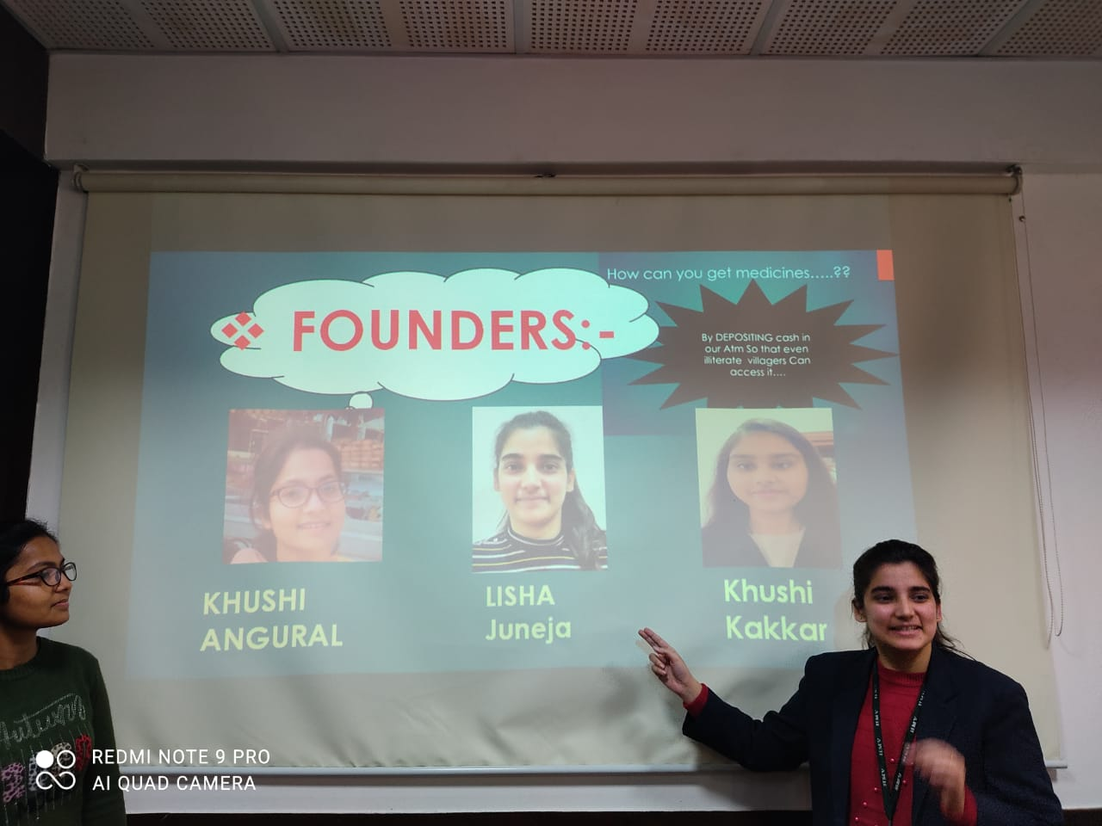

Innovation cell of Hans Raj Mahila Maha Vidyalaya, Jalandhar organized Idea Pitching Competition-2021 under the able guidance of Principal Prof. Dr. (Mrs.) Ajay Sareen. The Students of SSC II Commerce participated in this competition. Lisha Juneja, Khushi and Khushi Angural ranked first position. They presented their business plan based on the idea ‘Mini Pharmacy’. Gagandeep Kaur and Ramandeep Kaur presented their business idea on the clothing brand ‘Vastar’ and stood second. Business plan ‘Restaurant’ (Green city with amazed world) was presented by Sakshi Badola and Monika and ‘Detecting Chip’ was presented by Kriti and Prachi Sharma. They won consolation prize. Dr. Ajay Sareen appreciated the students and said that today’s generation thinks out of the box and represents their innovative, feasible and executable ideas. Principal Dr. Ajay Sareen and Mrs. Meenakshi Sayal, School Coordinator also congratulated all the winners. Principal Dr. Sareen encouraged them to keep participating in such competitions to gain more knowledge and information

THE BUSINESS PLAN OF HMV GIRLS EARNS RECOGNITION AT NATIONAL LEVEL

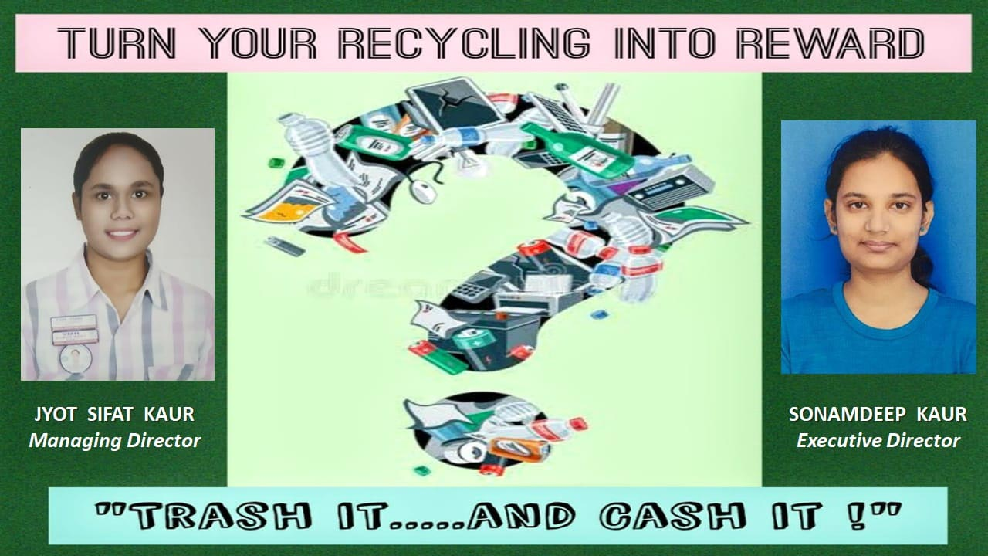

The students of B.Com, Financial Services Semester IV of Hans Raj Mahila Maha Vidyalaya, Jalandhar bagged 4th rank in ADBU Solution Competition 2021 organised by ADBU Innovation & Start up cell & Board of Research, Innovation & Consultancy (BRIC) catalyzed & supported by ASTE Council, Patent Information Centre, Govt. of Assam. The students were Km. Jyot Sifat Kaur and Km. Sonamdeep Kaur. The topics was “Turn your Recycling into Reward.”

WORLD BOOK AND COPYRIGHT DAY CELEBRATED MULTIFARIOUSLY BY HMV IIC AND IPR CELL

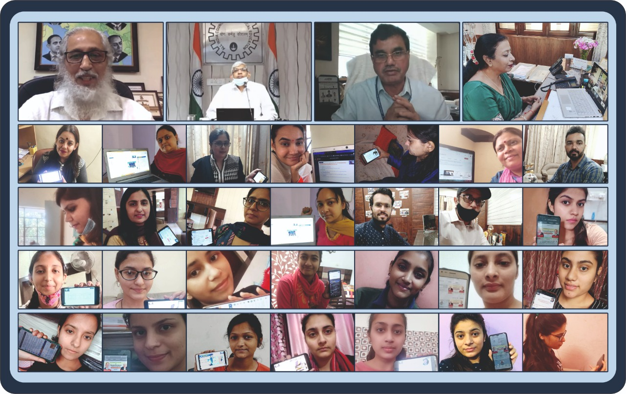

The Innovation Council of HMV celebrated the World Book and Copyright Day on a productive, creative and an energetic note under the dynamism of Prinicipal Prof. Dr. (Mrs.) Ajay Sareen and Dr. Anjana Bhatia, Incharge, IIC and IPR Cell. To begin with, the Student and faculty members of IIC attended an informative talk streamed live on Youtube by MHRD Innovation Council on the topic “From your PH.D/ Master’s Thesis to a Start Up. The Resource Person was Dr. Anil Deshpande, Founder and CMD, Persistent Systems, Session Chair was Prof. Anil Sahashrabuddhe, Chairman AICTE with Dr. M.P. Poonia, Vice Chairman, AICTE, Prof. Rajiv Kumar, Member Secretary, AICTE and Dr. Abhay Jere, Chief innovation Officer, MoE’s innovation Cell as distinguished Guests of Honour. Dr. Anil delivered a detailed talk on converting the idea of research into entrepreneurship

INTERNATIONAL CONFERENCE ON PLANT BIODIVERSITY AND ENVIRONMENT CONSERVATION

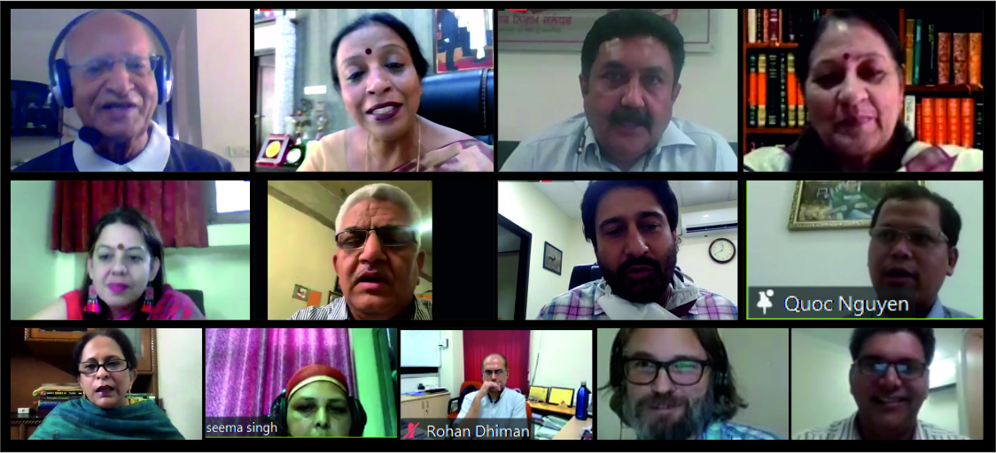

Hans Raj Mahila Mahavidyalaya, Jalandhar, Punjab once again added a first to its credit as the PG Department of Botany in collaboration with Punjab Biodiversity Board organized an e-International Conference on ‘Plant Biodiversity and Environment Conservation’ (ICPBEC -2021) on 20th – 21st May, 2021. This is the first conference of its kind in Punjab Region. The conference started with recitation of Gayatri Mantra and lighting of the lamp. The inaugural session commenced with the welcome address by Principal Prof. Dr. (Mrs.) Ajay Sareen, the chief inspiration and motivator behind this initiative. Principal Dr. Ajay Sareen welcomed Sh. Karnesh Sharma, IAS, Commissioner, Municipal Corporation, Jalandhar, the Chief Guest of the day, Dr. Neelima Jerath, Guest of Honour and Dr. Ramesh Arya, Vice President, DAV College Managing Committee, New Delhi. She highlighted the various initiatives already going on in HMV to conserve environment. She stressed upon the need to improvise our present lifestyle in a way that we can hand over a better planet to our future generation. The present pandemic has made us realize that unless we respect nature, we are in for very tough times. She acknowledged and appreciated the efforts and extensive planning done by Dr. Anjana Bhatia, Head of Botany Department and Coordinator of this International Conference and her entire team. She extended a very warm welcome to all the eminent scholars from across the globe.

